Пример №1

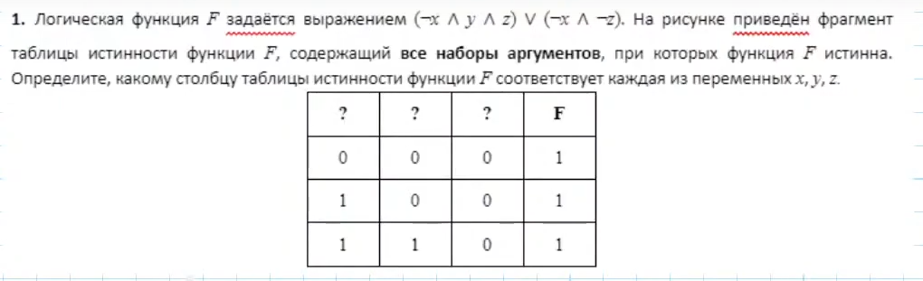

yzx

|  |  |  |  |
| --- | --- | --- | --- |
| x | y | z | f |
| 0 | 0 | 0 | 1 |
| 0 | 1 | 0 | 1 |
| 0 | 1 | 1 | 1 |

Пример №2

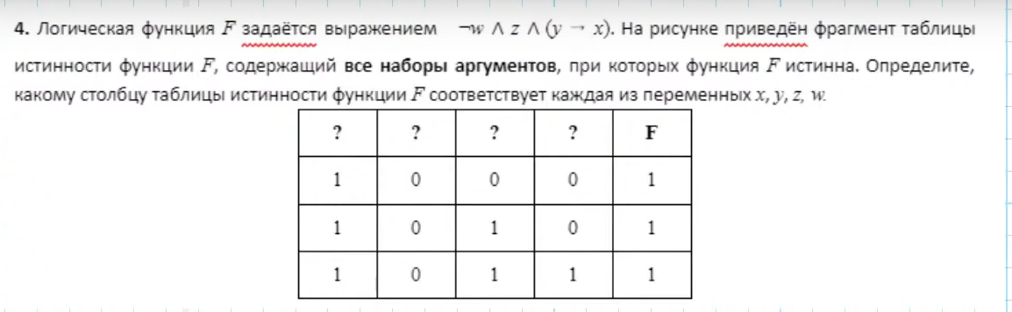

zwxy

|  |  |  |  |  |
| --- | --- | --- | --- | --- |
| x | y | w | z | f |
| 0 | 0 | 0 | 1 | 1 |
| 1 | 0 | 0 | 1 | 1 |
| 1 | 1 | 0 | 1 | 1 |

Пример №3

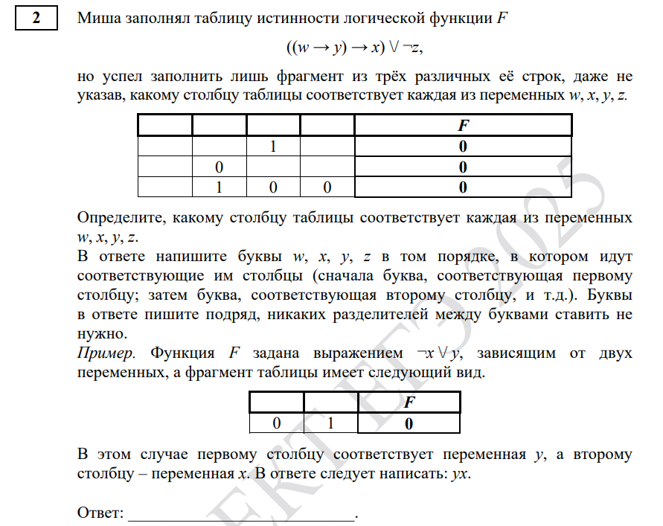



|  |  |  |  |  |
| --- | --- | --- | --- | --- |
| x | y | w | z | f |
| 0 | 0 | 0 | 1 | 0 |
| 0 | 1 | 0 | 1 | 0 |
| 0 | 1 | 1 | 1 | 0 |

Пример №4

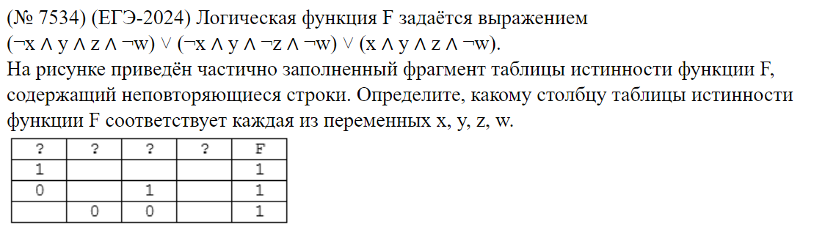



|  |  |  |  |  |
| --- | --- | --- | --- | --- |
| x | y | w | z | f |
| 0 | 1 | 0 | 0 | 1 |
| 0 | 1 | 0 | 1 | 1 |
| 1 | 1 | 0 | 1 | 1 |

Пример №5

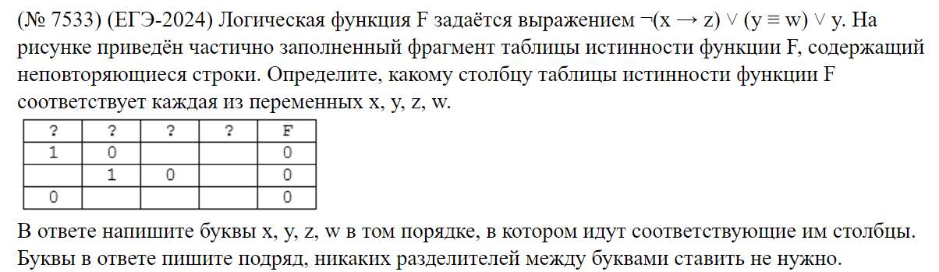



|  |  |  |  |  |
| --- | --- | --- | --- | --- |
| x | y | w | z | f |
| 0 | 0 | 1 | 0 | 0 |
| 0 | 0 | 1 | 1 | 0 |
| 1 | 0 | 1 | 1 | 0 |

Пример №6

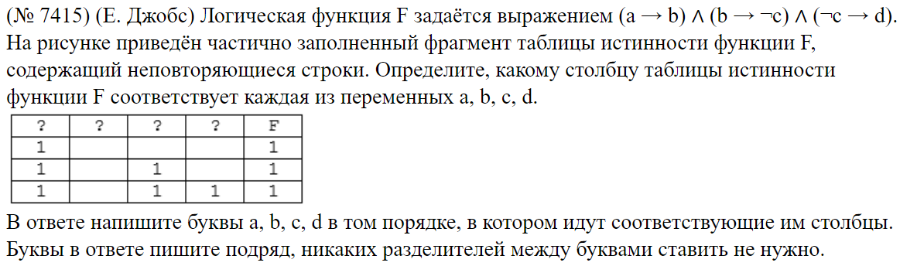



|  |  |  |  |  |
| --- | --- | --- | --- | --- |
| a | b | c | d | f |
| 0 | 0 | 0 | 1 | 1 |
| 0 | 0 | 1 | 0 | 1 |
| 0 | 0 | 1 | 1 | 1 |
| 0 | 1 | 0 | 1 | 1 |
| 1 | 1 | 0 | 1 | 1 |

Первый столбец d строка 2 минус

|  |  |  |  |  |
| --- | --- | --- | --- | --- |
| d | a | b | c | f |
| 1 | 0 | 0 | 0 | 1 |
| 1 | 0 | 0 | 1 | 1 |
| 1 | 0 | 1 | 0 | 1 |
| 1 | 1 | 1 | 0 | 1 |

Пример №7

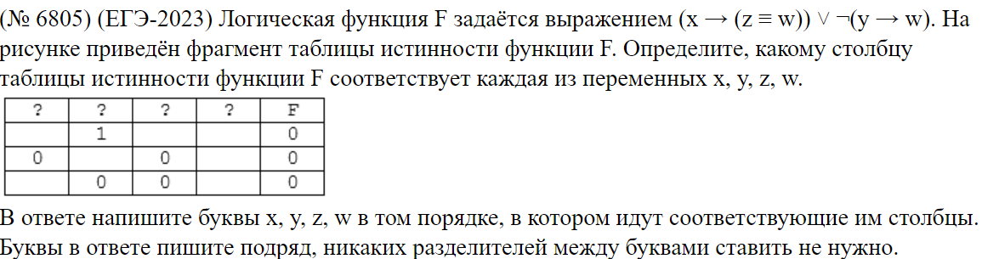



|  |  |  |  |  |
| --- | --- | --- | --- | --- |
| x | y | w | z | f |
| 1 | 0 | 0 | 1 | 0 |
| 1 | 0 | 1 | 0 | 0 |
| 1 | 1 | 1 | 0 | 0 |

Пример №8

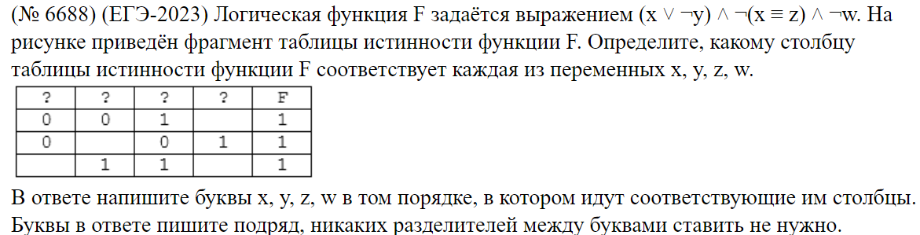



|  |  |  |  |  |
| --- | --- | --- | --- | --- |
| x | y | w | z | f |
| 0 | 0 | 0 | 1 | 1 |
| 1 | 0 | 0 | 0 | 1 |
| 1 | 1 | 0 | 0 | 1 |

Пример №9

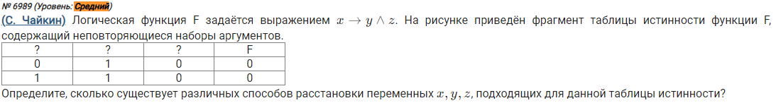



|  |  |  |  |
| --- | --- | --- | --- |
| x | y | z | f |
| 1 | 0 | 0 | 0 |
| 1 | 0 | 1 | 0 |
| 1 | 1 | 0 | 0 |

Пример №10

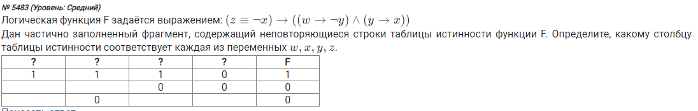



|  |  |  |  |  |
| --- | --- | --- | --- | --- |
| x | y | w | z | f |
| 0 | 1 | 0 | 1 | 0 |
| 0 | 1 | 1 | 1 | 0 |
| 1 | 1 | 0 | 1 | 1 |
| 1 | 1 | 1 | 0 | 0 |